Navigating to the Individual Summary Profile (ISP)
- Go to ohid.ohio.gov.
- Click Log in.
- Enter your credentials (OHID number) and click Log in.
- Click the DODD Applications Prod tile.

- In the top left, click the application launcher ( ).
- Click the Individual Summary Profile tile.

Checking the Person’s Gender and Date of Birth in ISP
- Go to an Individuals’s record.
- Under the Details tab, scroll down to the Demographics section.
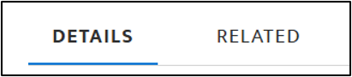
- Ensure all information is correct, specifically the Gender and Birthdate fields.

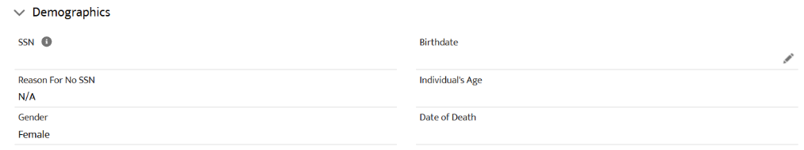
If the information is incorrect, immediately notify the reporting County Board.

Checking Residency in ISP
- Go to an Individual’s record.
- Under the Details tab, scroll down to the Contact Information section.
- Ensure all information is correct, specifically the Residence County and Facility fields.
