Navigating to IDS
- Click Log In in the top right corner at dodd.ohio.gov.
- Enter credentials, then click Continue.
- Click the Applications tab in the blue navigation bar at the top.
- Click the IDS tile.
- Click the IDS Application tile.

How to check whether Individuals are correctly enrolled in IDS

- Go to an Individual’s record.
Global Search can be used by clicking the Magnifying Glass in the navigation bar at the top of the page.
- Click the County Information tab.
You may have to click the 3 dots (…) to see the expanded list depending on screen size.
- Check that Enrollment, Termination, and Reenrollment dates are correct.
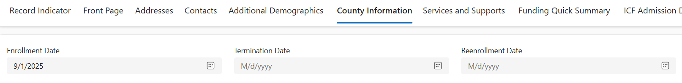
If the person has passed and was receiving services, please update the Date of Death to prevent them from being pulled.

Checking Services and Supports in IDS
- Go to an Individual’s record.
- Click the Services and Support tab.
You may have to click the 3 dots (…) to see the expanded list depending on screen size.
- Review the following Services and Supports.
- Ohio Department of Aging Day Support - Facility
- Ohio Department of Aging Day Support – Community
- Adult Day Support – Facility
- Adult Day Support - Community
- Vocational Habilitation – Facility
- Vocational Habilitation - Community
- Group Employment Supports
- Individual Employment Supports
- Career Planning
- Ensure Competitive Employment, at the bottom of the page, is marked appropriately.
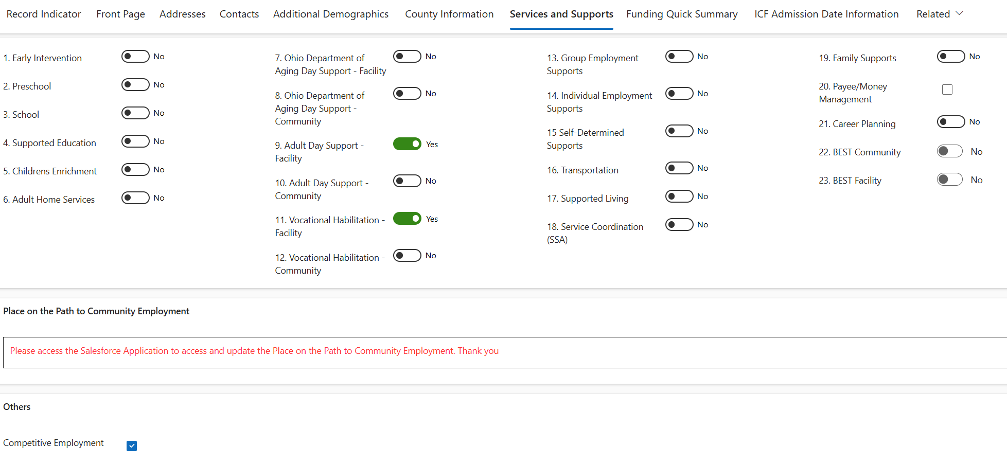

Navigating to the Individual Summary Profile (ISP)
- Go to ohid.ohio.gov.
- Click Log in.
- Enter your credentials (OHID number) and click Log in.
- Click the DODD Applications Prod tile.

- In the top left, click the application launcher ( ).
- Click the Individual Summary Profile tile.
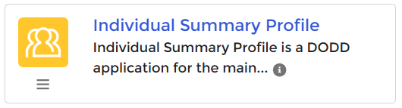
If you don’t see the Individual Summary Profile, please speak to an admin within your organization; they should be able to provide access through User Management.

Check existing Paths to Community Employment (PPCE) data in the Individual Summary Profile (ISP)
- Go to a person account record.
- Click the Related tab.
- Scroll down to the Paths to Community Employment section and review the data.
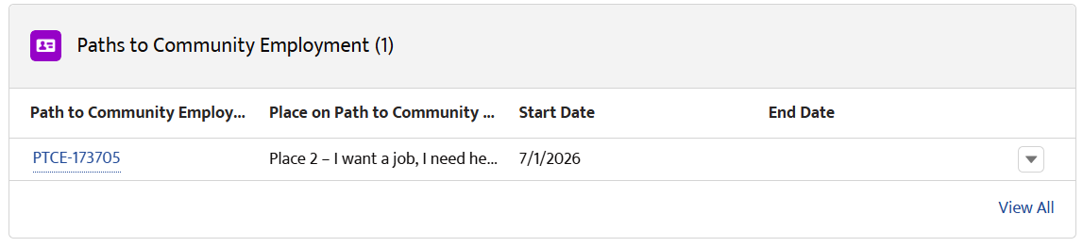

Creating a new Path to Community Employment record
- Go to a person account record.
- Click the dropdown arrow in the top right and select Create New.
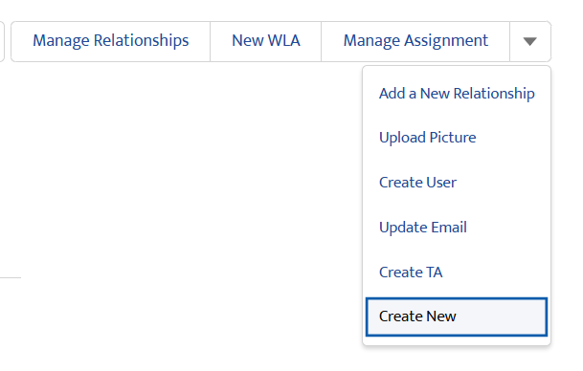
- Follow the prompt to enter in new PPCE data.

