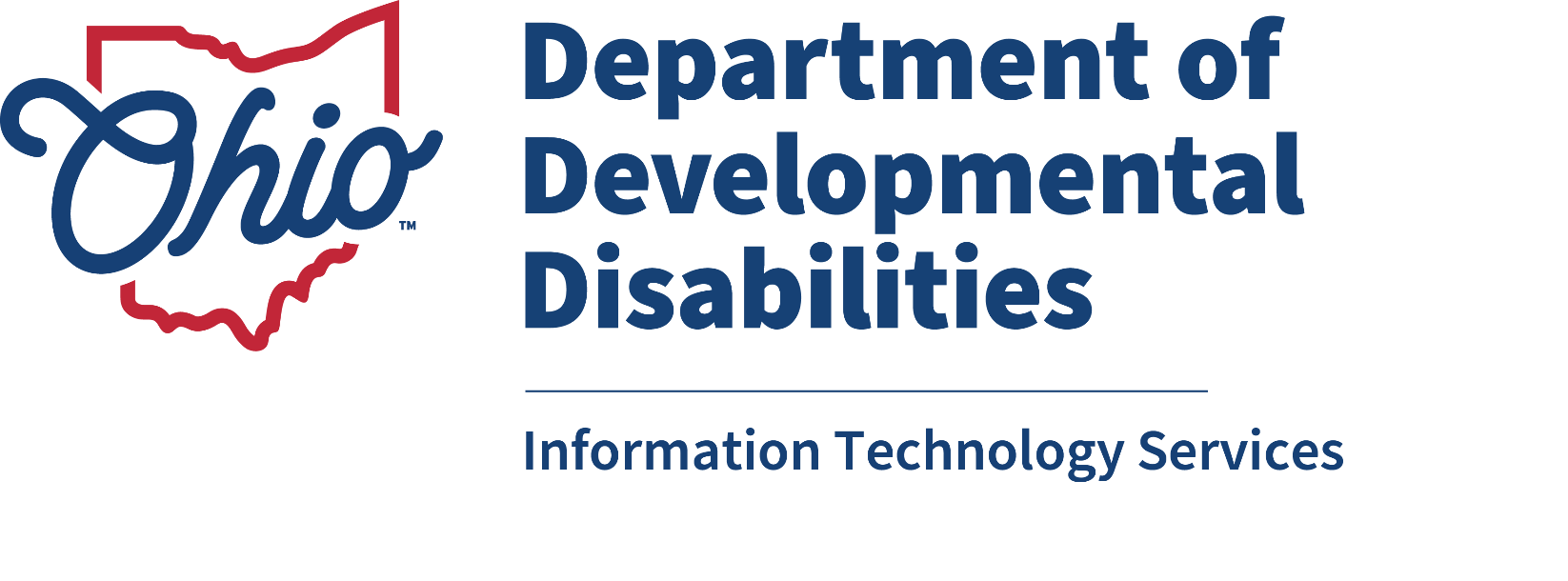

Outcome Tracking System (OTS)

User Guide

April 2026

Department of Developmental Disabilities
Division of Information Technology Services
30 East Broad Street, 13th Floor
Columbus, Ohio 43215

Table of Contents
Overview 1
The OTS Process 1
How Data is Imported into OTS 1
The Outcome Tracking System Application 2
Who Has Access? 2
Accessing OTS 2
The OTS Dashboard (All Users) 3
ICF, DC, and Provider User Dashboard 4
Questionnaire Queue (All Users) 4
Advanced Search (All Users) 5
Assignment Queue (County Board, ICF, or DC Users) 7
County Board Users 7
ICF and DC Users 7
Assigning Questionnaires to a Provider (County Board, ICF, or DC Users) 8
Completing the Questionnaire (All Users) 11
Subsequent Year Reporting (All Users) 13
Place on the Path to Community Employment (County Board Users) 16
Place on the Path to Community Employment (ICF and DC Users) 18
Performance Report (County Board Users) 21

Overview
The Outcome Tracking System (OTS) application replaced the Employment First Outcome Tracking System (EF OTS) in October 2019. The new OTS application captures how people spend their days. It looks at systems and services outcomes: those larger outcomes that are happening with services. This new application does not focus on individual outcomes that are identified within a person’s plan (ISP/IP).
The Ohio Department of Developmental Disabilities (DODD) will use the data from the OTS application to better align policies, procedures, and legislation that will improve how people live, work, play, and thrive in their communities.

The OTS Process
OTS will include DODD certified providers that are providing Adult Day and Employment Supports, intermediate care facilities (ICFs) and developmental centers (DCs), and county boards of developmental disabilities (CBs). Participation in OTS is a requirement for employment providers per the Employment First Rule: Ohio Administrative Code 5123:2-2-05. Currently, participation for Adult Day Services providers, ICFs, and DCs is not required, however, this data is valuable and DODD asks that all providers participate.
Adult Day and Employment providers, ICFs, DCs, and CBs will enter data into OTS once a year for the people to whom they have provided employment services, Adult Day Supports, and Active Treatment in the month of September. Providers will have a six month timeframe to complete questionnaires: October 1 through March 31.
The OTS questionnaire contains six “yes or no” questions for providers to answer. While two of the questions are optional, answering all six questions creates a more complete picture of how people are spending their days in their communities. Employment providers are required to answer questions #1 through #4 and their associated sub-questions. Questions #5 and #6 are not required per rule for any provider, but DODD encourages all providers to answer them to help DODD better understand how people live, work, and play in their communities. All data will be shared on an external website for all Ohioans to see, including the aggregate data from questions #5 and #6.

How Data is Imported into OTS
For Adult Day and Employment providers, people are added into the providers’ respective dashboards on September 10 if the provider has billed certain waiver services - Adult Day, Vocational Habilitation, Group Employment, Individual Employment, and Career Planning (Benefits Education and Analysis, Career Discovery, Career Exploration, Employment-Self-Employment Plan, Job Development, Situational Observation and Assessment, Worksite Accessibility, and Self-Employment Launch)—within the last 12 months.
All people residing in an ICF or DC as of September 10 will be added to the respective dashboards for each facility.
For county boards, people are added to the respective dashboards based on the services and supports selected within CRM-IDS, as long as the person is considered active. A person is considered active when there is no termination date, no date of death, and the person has an enrollment or re-enrollment date.
People receiving Adult Day or Employment services on local funds will be assigned to the appropriate provider(s) by the county board. People receiving Active Treatment that resembles an Adult Day or Employment service will be assigned to the appropriate provider by the ICF or DC. If an ICF or DC has a contract with a provider that is not a DODD provider, the ICF or DC will be responsible for entering the data.

The Outcome Tracking System Application

Who Has Access?
Anyone with access to the previous Employment First Outcome Tracking System application as of June 27, 2019 will automatically have access to the Outcome Tracking System application. All other users will need to request access.
To use the Outcome Tracking System (OTS), you’ll need an OHID account and access to the OTS application in OHID > DODD Applications. See Getting Started with DODD Applications (https://dodd.ohio.gov/getting-started-dodd-apps) for these instructions:
- Creating an OHID
- Logging in to the OHID Site
- OHID Support Information
- Adding and Opening DODD Applications (including legacy applications, which use the My DODD application tile for access).

Accessing OTS
- Click Applications in the top menu. Click OTS.
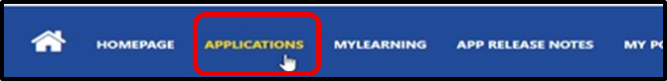
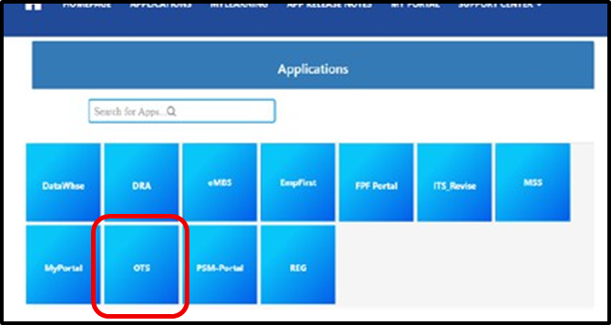

The OTS Dashboard (All Users)
The OTS Dashboard is the home screen for the OTS Application. You can always return to the OTS Dashboard by clicking the Dynamics 365 icon.
The OTS Dashboard includes the up-to-date status for the questionnaires in your queue. You can see immediately how many questionnaires are in your queue overall, how many have not been started, how many are in progress, and how many have been completed.
The status rings do not count the number of people, but the number of questionnaires. You may have multiple questionnaires for the same person if you have provided services under multiple contract numbers, such as different agencies operating under the same parent agency.

County Board User Dashboard
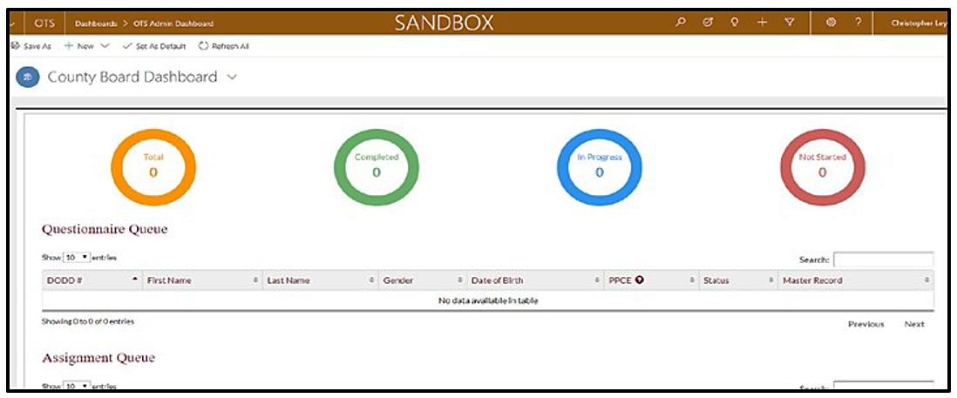

ICF, DC, and Provider User Dashboard
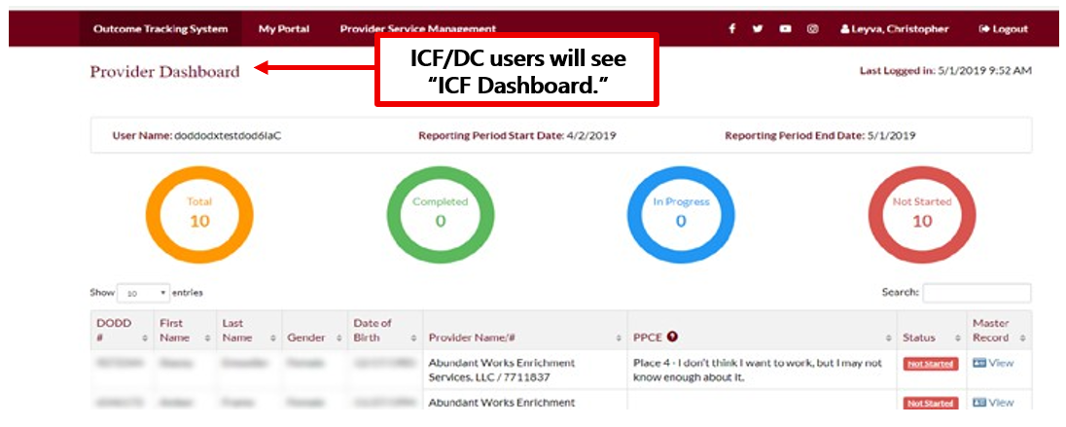

Questionnaire Queue (All Users)
The Questionnaire Queue lists the people whose questionnaires you are required to complete. For intermediate care facility users, developmental center users, and other providers, the
Questionnaire Queue will include people who have received Adult Day Support, employment services, or Active Treatment that resembles an Adult Day or employment services from the provider or facility. Providers will also see anyone who has been assigned to them by a county board, ICF, or DC.
The Questionnaire Queue includes the person’s DODD number, first and last name, gender, date of birth, and Place on the Path to Community Employment. You can also see each questionnaire’s status and a Master Record that shows a read-only document of all data submitted by all providers working with the person.
The search function can be used to find the record for a specific person. You can search by any category, even using partial words to search.
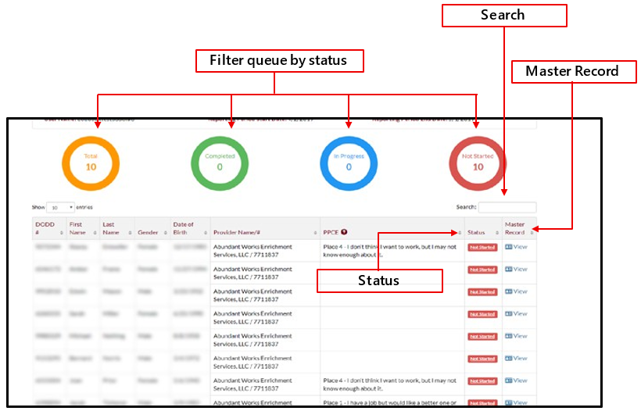

You can sort the Questionnaire Queue by any column using the sort arrows in each column heading.

Advanced Search (All Users)
With the advanced search function, you can search using the person’s information, including name, DODD number, gender, or date of birth. You can also search by provider or facility number, facility name, or current and previous reporting periods.
County board users can search for anyone in their reporting county and anyone who has been assigned to the county board.
ICF and DC users can search anyone who is residing in the facility and anyone who has been assigned to the facility. If the facility also provides waiver services, those people will also be represented in the search function.
Provider users can only search people for whom they have billed services or people who have been directly assigned to the provider.
- Enter the search terms in the desired field or fields, then click Search.
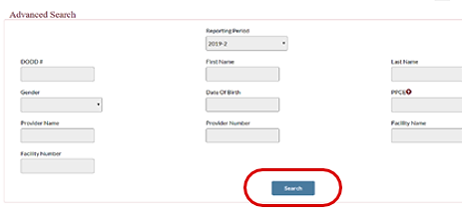
- Your results will be displayed.
County boards and ICFs can assign people to providers from this section.
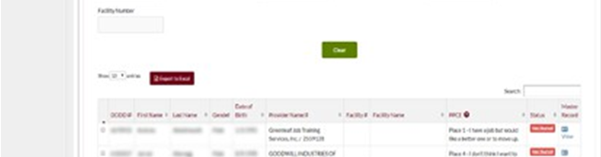
ICF users can only assign people who are residing in the facility if the ICF also provides waiver services.
- Click Clear to clear the results and begin a new search.
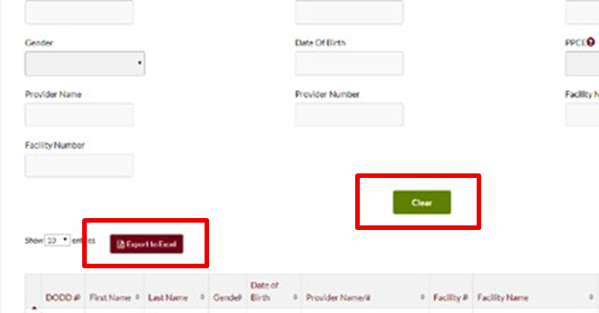
- Click Export to Excel to download your search as an Excel spreadsheet.

Assignment Queue (County Board, ICF, or DC Users)
The Assignment Queue is where county board, ICF, or developmental center users assign a questionnaire to the appropriate adult day or employment provider(s), providers that are supporting someone who is competitively employed, or providers using locally-funded monies.
For ICF and DC users, the Assignment Queue and Questionnaire Queue are combined.
County board users cannot see people who do not have their county listed as the reporting county or who are living in an ICF, unless that person was directly assigned to the county board.

County Board Users
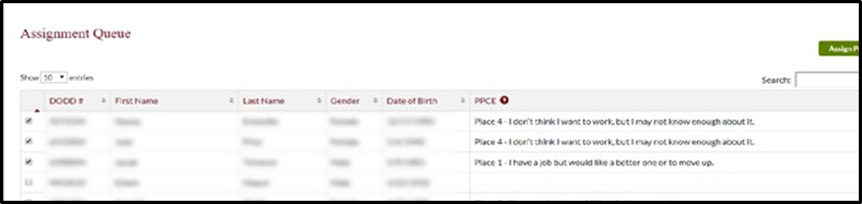

ICF and DC Users
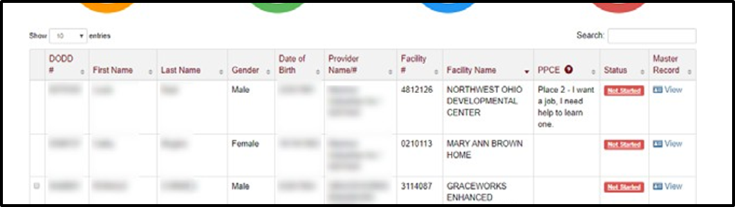

Assigning Questionnaires to a Provider (County Board, ICF, or DC Users)
- Begin at the OTS Dashboard and scroll down to the Assignment Queue.
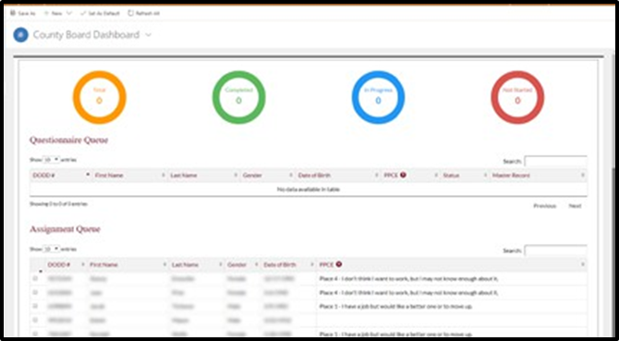
- Click the boxes to select the people whose questionnaires will be assigned.
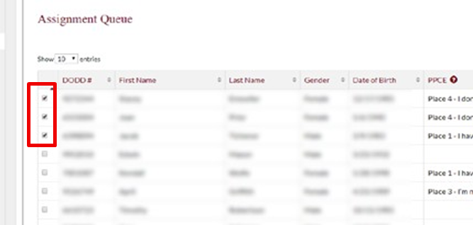
- Click Assign Provider.
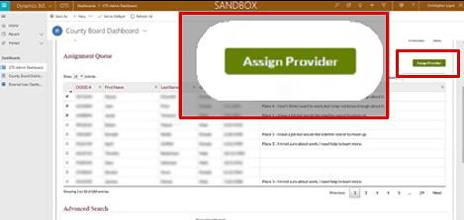
- A pop-up will appear. Click Get Provider.
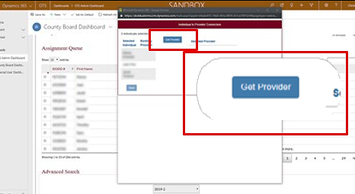
- Type the provider’s name or contract number into the search field.
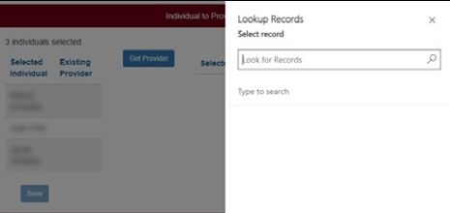
- Click the provider’s name. The provider will be selected. Add additional providers to the selection using this same process. Add additional providers to the selection using this same process.
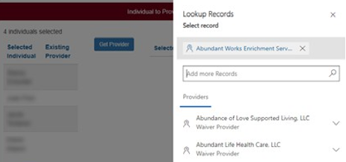
- Once all providers have been selected, click Add.
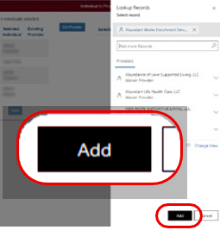
- Click Save.
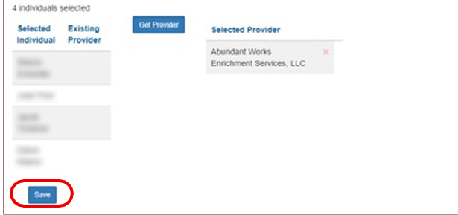

A provider cannot be unassigned once you click Save. Click the “x” to remove a provider before saving. If you need to remove a provider after saving, contact employmentfirst@dodd.ohio.gov.
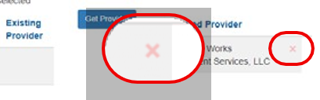
- Click Yes to confirm the assignment of the questionnaire(s) to the selected provider(s).
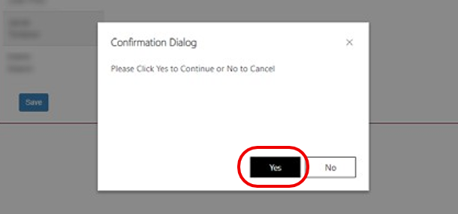
- Close the pop-up window your changes. Assignments occur in real time and are immediately available on the provider or county board’s Questionnaire Queue.

Completing the Questionnaire (All Users)
- Begin at the OTS Dashboard and scroll down to the Questionnaire Queue.
For county board users, if a person’s questionnaire is not already in your Questionnaire. Queue, you must first assign the questionnaire to the county board.
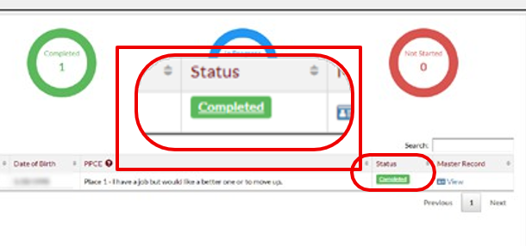
- Click the questionnaire’s status.
- Answer the six questions with Yes or No regarding the supports you provided to the person during the month of September.
- Click Save and Continue to save your progress and continue working, or click Save to finish the questionnaire later.
- Any questions that have been answered as Yes will require sub-questions to be answered.
You can add multiple jobs by clicking the Add button at the bottom of the page.
Complete the sub-questions and click Save and Continue.
You are only responsible for entering data for the supports that you provided in the month of September. If a person is competitively employed with no supports, then the county board is responsible for entering this data.
If a person is competitively employed and also lives in an ICF or DC, that facility is responsible for entering this data.
If Active Treatment is provided by a contracted agency that is not a DODD provider, the ICF or DC will be responsible for entering the data for those questionnaires.
- A summary of your answers is provided for your review once you have completed all necessary sub-questions.
To make a correction, click the Edit button for that section. I
- If everything is correct, click Submit.
It is important to ensure all the information is correct. Once the questionnaire has been submitted, no corrections can be made by anyone, including DODD.
- You will return to the OTS Dashboard and the questionnaire will now have a status of Completed.

Subsequent Year Reporting (All Users)
If you answer Yes to any of the six main questions in the questionnaire, the answers for the related sub-questions will be available in subsequent years to make completing the questionnaire fast and easy.
The answers to the sub-questions from previous years are available even if you did not previously complete a person’s questionnaire.
If you answered Yes to any of the six main questions in a previous year, your previous answers to the related sub-questions will be already pre-populated when you answer Yes to the same question.
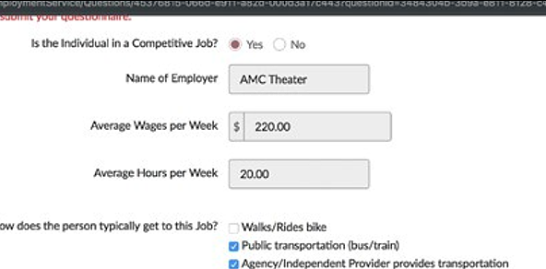
If you did not answer the questionnaire for the person, entries from previous providers will be available in a drop-down menu.
Select the job that you are now supporting, and the previous answers will populate.
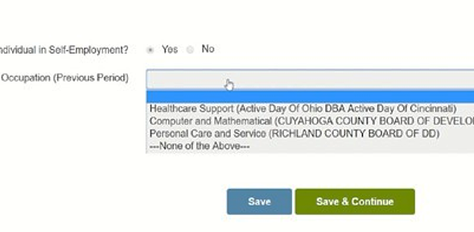
It is important to review any information from previous years to ensure it is correct for data integrity. Once the questionnaire has been submitted, no corrections can be made by anyone, including DODD.
Review the information and make any necessary revisions or additions, then click Save and Continue to save your progress and continue working or click Save & Exit to finish the questionnaire later.
It is important to review any information from previous years to ensure it is correct for data integrity. Once the questionnaire has been submitted, no corrections can be made by anyone, including DODD.

Review the information and make any necessary revisions or additions, then click Save and Continue to save your progress and continue working, or click Save & Exit to finish the questionnaire later.
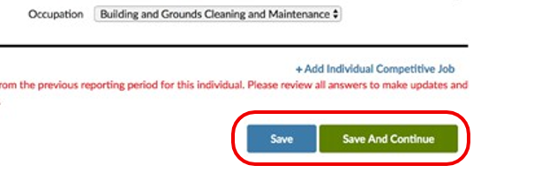
To make a correction, click the Edit button for that section.
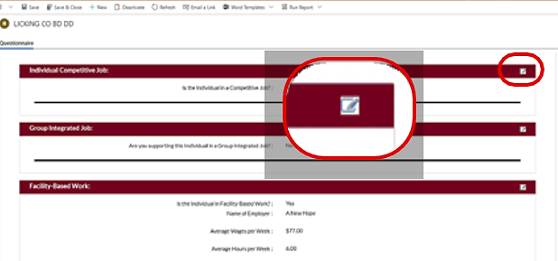
If everything is correct, click Submit.
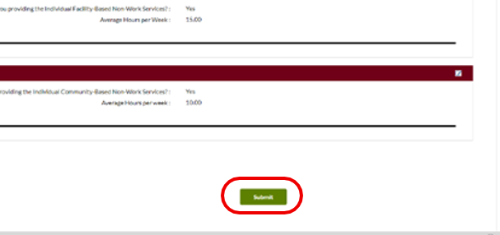
Once the questionnaire has been submitted, no corrections can be made by anyone, including DODD.
You will return to the OTS Dashboard, and the questionnaire will now have a status of “Completed.”
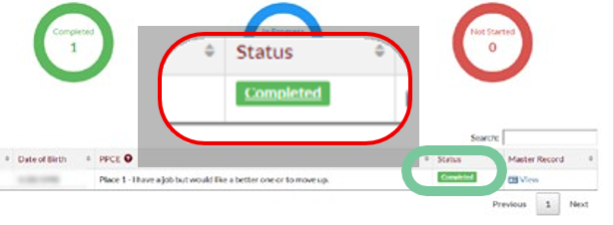

Place on the Path to Community Employment (County Board Users)
- Log into OHID: http://dodd.ohio.gov.
- In the legacy applications portal, click Applications in the top menu.
- Click the tile that includes LOC (Level of Care System). Continue with any additional login prompts.
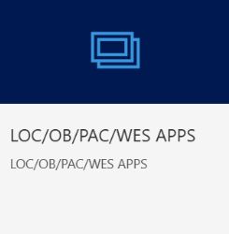
- Search for the person and click on their name.
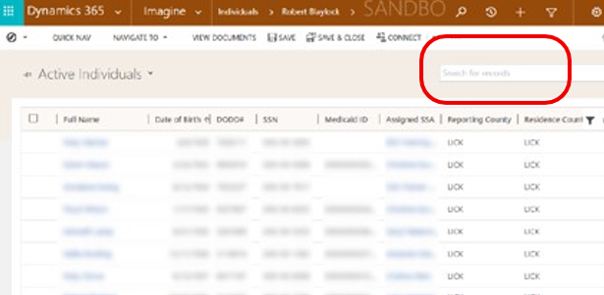
- You will be directed to the home page for that person.
Scroll down and click the “Services and Supports” section.
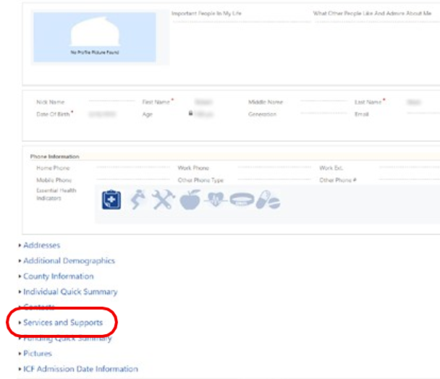
- Scroll below the Service and Supports section and click “+” next to “Place on the Path to Community Employment.”
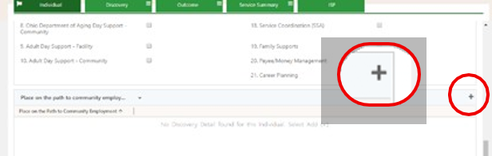
- A pop-up window will appear. Select the person’s Place on the Path to Community Employment.
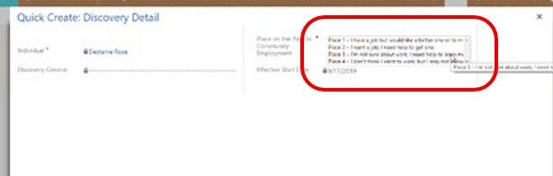
- Click Save.
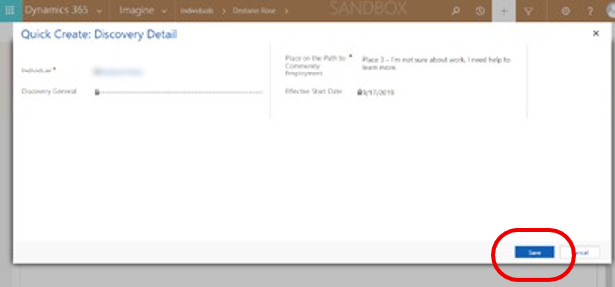
Make any other updates to the person’s services and supports as necessary while updating the Place on the Path to Community Employment.
Data from CRM-IDS about a person’s services and supports and Place on the Path to Community Employment is imported into OTS annually on September 10. Make sure this information is updated before that date.

Place on the Path to Community Employment (ICF and DC Users)
- Log into OHID: http://dodd.ohio.gov.
- In the legacy applications portal, click Applications in the top menu.
- Click My Portal. Continue with any additional login prompts.

- You will be directed to the portal dashboard. Click the appropriate facility (if multiple are shown).
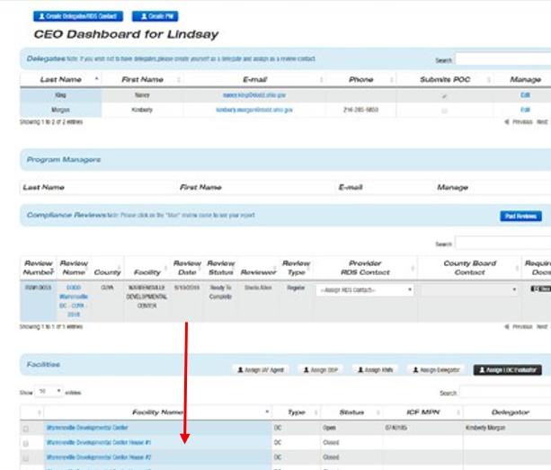
- Scroll down to the Individuals section and click the person’s name.
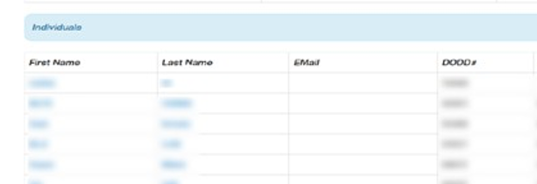
- On the person’s profile page, click the Path to Community Employment tab.
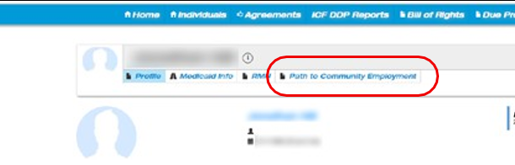
- Click Add Community Employment.
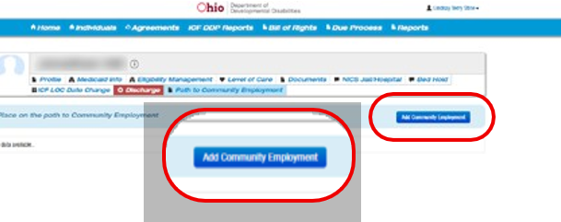
- A pop-up screen will appear. Select the person’s Place on the Path to Community Employment.
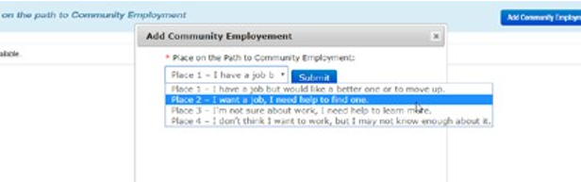
- Click Submit.
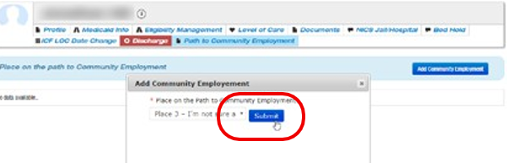
Data from the Portal about a person’s Place on the Path to Community Employment is imported into OTS annually on September 10. Make sure this information is updated before that date.

Performance Report (County Board Users)
The Performance Report is available throughout the reporting period and allows the county board to monitor completion of the questionnaires by all providers within their county.
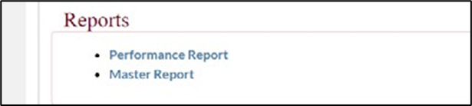
The report includes the total number of questionnaires, the percentage of questionnaires that are complete by each provider, and counts for how many questionnaires:
- Have not started
- Are in progress
- Are completed by each provider
County boards can see and export individual details as an Excel document if needed.

